

**American International University- Bangladesh**

**CSC 3215: Web Technologies**

**CO2 and CO4 Evaluation**

**Finished Project Report**

**Fall 2020-2021**

**Project Title: School Management System**

**Section: D**

|  |  |
| --- | --- |
| Student Name | Student Id |
| **Shawon, Md. Asif Reza** | 17-34335-1 |
| **Mondol, Dipto** | 17-34833-2 |
| **Afrin, Sadia** | 17-34904-2 |
|  |  |

**Project Description:**

*Our project is on School Management System. Now a day’s education plays a great role in development of any country. Many of education organizations try to increase education quality. One of the aspects of this improvement is managing of school resources. School Management System carried on by any individual or institution engaged in providing a services to students, teachers, guardians and other persons are intermediary that performs one or more of the following functionalities – Admin/Teacher/Student Registration, Teacher/Student List, Student Attendance, Routine, Result Management, Payroll & Accounts. Admin can manage login for students/teachers ,can send message to Teacher/Students. Teacher can upload notes,notice,marks ,attendance and student can see these easily . School Management System is such a service which provides all services for an educational institute to make our life easier and faster by assuring its performance. Easy User Management System, Easy Attendance System. We used database and database technology are having a major impact on the growing use of computers. The implementation of the system was done using web technologies and XAMPP Control Panel technologies, allowing system to be run in Windows OS. Our project is user friendly. Also in this digital era of life most of the educational institute adopting the idea of school management system. So, this system becoming demandable day by day.*

**Project Folder Structure:**

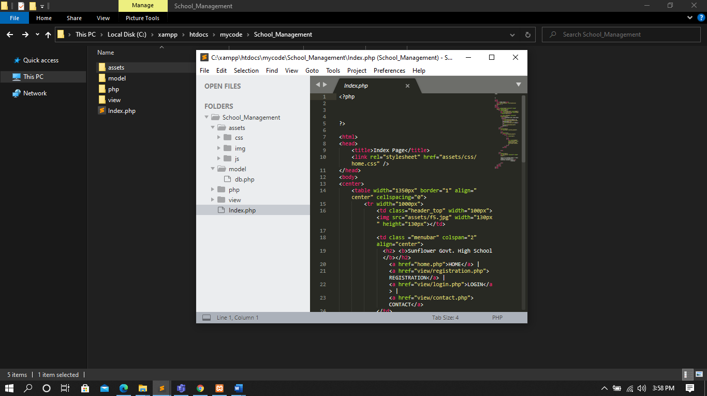

**Core Modules of the Project:**

***login.php***

*<?php*

*global $name;*

*include('../php/logincheck.php');*

*//session_start();*

*if(isset($_SESSION['id']))*

*{*

*header('Location:teacher_home.php');*

*}*

*?>*

*<!DOCTYPE html>*

*<html lang="en" dir="ltr">*

*<head>*

*<meta charset="UTF-8">*

*<title>Login</title>*

*<link rel="stylesheet" href="../assets/css/loginstyle.css">*

*</head>*

*<body>*

*<div class="center">*

*<h1>Login</h1>*

*<form method="post">*

*<div class="txt_field">*

*<input type="text" value="" name="id" required>*

*<span></span>*

*<label>UserId</label>*

*</div>*

*<div class="txt_field">*

*<input type="password" value="" name="password" required>*

*<span></span>*

*<label>Password</label>*

*</div>*

*<input type="submit" name="submit" value="Login">*

*</form>*

*</div>*

*</body>*

*</html>*

***search.php***

*<?php*

*//session starts*

*session_start();*

*if(isset($_SESSION['id']))*

*{*

*$id = $_SESSION['id'];*

*}else {*

*header("location:login.php");*

*}*

*include('../php/teacherHomeCheck.php');*

*?>*

*<!DOCTYPE html>*

*<html>*

*<head>*

*<title>Search Page</title>*

*<script>*

*function showmyuser() {*

*var id= document.getElementById("id").value;*

*var xhttp = new XMLHttpRequest();*

*xhttp.onreadystatechange = function() {*

*if (this.readyState == 4 && this.status == 200) {*

*document.getElementById("mytext").innerHTML = this.responseText;*

*}*

*else*

*{*

*document.getElementById("mytext").innerHTML = this.status;*

*}*

*};*

*xhttp.open("POST", "/mycode/dipto1/php/getuser.php", true);*

*xhttp.setRequestHeader("Content-type", "application/x-www-form-urlencoded");*

*xhttp.send("id="+id);*

*}*

*</script>*

*</head>*

*<body>*

*<center>*

*<table border="1" cellspacing="0" width="50%" >*

*<tr>*

*<td colspan="2" align="center"><h1>*

*Welcome <?php echo $_COOKIE['userName']; ?><br>*

*<?php echo $id; ?>!*

*</h1></td>*

*</tr>*

*<tr>*

*<td width="200px">*

*<ul>*

*<li>*

*<a href="profile.php">Profile</a>*

*<br/>*

*</li>*

*<li>*

*<a href="search.php">Search</a>*

*<br>*

*</li>*

*<li>*

*<a href="grade.php">Grade</a>*

*<br/>*

*</li>*

*<li>*

*<a href="notes.php">Notes</a>*

*<br/>*

*</li>*

*<li>*

*<a href="notice.php">Notice</a>*

*<br>*

*</li>*

*<li>*

*<a href="class.php">Student Details</a>*

*<br>*

*</li>*

*<li>*

*<a href="classSchedule.php">Class schedule</a>*

*<br>*

*</li>*

*<li>*

*<a href="updateGrade.php">Update Grade </a>*

*<br>*

*</li>*

*<li>*

*<a href="attendance.php">Student Attendance</a>*

*<br>*

*</li>*

*<li>*

*<a href="email.php">Email</a>*

*<br>*

*</li>*

*<li>*

*<a href="conparent.php">Contact with Parent</a>*

*<br>*

*</li>*

*<li>*

*<a href="salaryhistory.php">Salary</a>*

*<br>*

*</li>*

*<li>*

*<a href="adminNotice.php">Admin Notice </a>*

*<br>*

*</li>*

*<li>*

*<a href="paymentDetails.php">Payment Details</a>*

*<br>*

*</li>*

*<li>*

*<a href="../php/logout.php">logout</a>*

*<br>*

*</li>*

*</ul>*

*</td>*

*<td width ="600px" height="400px">*

*<h2>Search Student Details by Id</h2>*

*<input type="text" name ="id" id="id"/>*

*<button onclick="showmyuser()">Search</button>*

*<p id="mytext"></p>*

*</td>*

*</tr>*

*</table>*

*</center>*

*</body>*

*</html>*

***formValidation.js***

"use strict"

function NameValidation()

{

let data= document.getElementById('name').value;

if(data == ''){

document.getElementById('head').innerHTML = 'Empty name field ';

}

else if(data.length <3){

document.getElementById('head').innerHTML = 'Name required three words';

}

else if (data >=0 && data <=9){

document.getElementById('head').innerHTML = 'Name is invalid';

}

else if(data >='a' && data <='z' || data>='A' && data <='Z' || data == '.' || data == '-'){

document.getElementById('head').innerHTML = data;

}

else{

document.getElementById('head').innerHTML = 'Name is invalid';

}

}

function IdValidation(){

let data= document.getElementById('id').value;

if(data >=0 || data <=9){

document.getElementById('head').innerHTML = data;

}

else{

document.getElementById('head').innerHTML = 'Id is invalid !';

}

}

function PasswordValidation(){

let data= document.getElementById('password').value;

let dataone= document.getElementById('cpassword').value;

if(data.length <6){

document.getElementById('head').innerHTML = 'Invalid Password';

}

else{

document.getElementById('head').innerHTML = data;

}

}

function EmailValidation()

{

let data= document.getElementById('email').value;

if(data == ''){

document.getElementById('head').innerHTML = 'Empty Name field ';

}

else if(data.length <3 ){

document.getElementById('head').innerHTML = 'Email is invalid !';

}

else if( data.includes("@gmail.com")){

document.getElementById('head').innerHTML = data;

}

else if( data.includes("@yahoo.com")){

document.getElementById('head').innerHTML = data;

}

else if( data.includes("@.edu")){

document.getElementById('head').innerHTML = data;

}

else{

document.getElementById('head').innerHTML = 'Email is invalid !';

}

}

function GenderValidation()

{

if(document.getElementById('male').checked ==true ){

document.getElementById('head').innerHTML = "male.value";

}

else if(document.getElementById('female').checked ==true){

document.getElementById('head').innerHTML = female.value;

}

else{

document.getElementById('head').innerHTML = others.value;

}

}

function NumberValidation(){

let data= document.getElementById('phone').value;

if(data.length==11 && data >=0 || data <=9){

document.getElementById('head').innerHTML = data;

}

else{

document.getElementById('head').innerHTML = 'Phone no is invalid !';

}

}

|  |  |  |  |  |  |
| --- | --- | --- | --- | --- | --- |
| **CO2 and CO4 Evaluation: Project Report Evaluation** | | | | | |
| **Completeness**  **(5)** | **Validation**  **(5)** | **Feature Implementation**  **(5)** | **Concept Understanding**  **(5)** | **Promptness (5)** | **Total (25)** |
|  |  |  |  |  |  |
|  | | | | | |